**DocuSign Template Setup**

* Create account in DocuSign

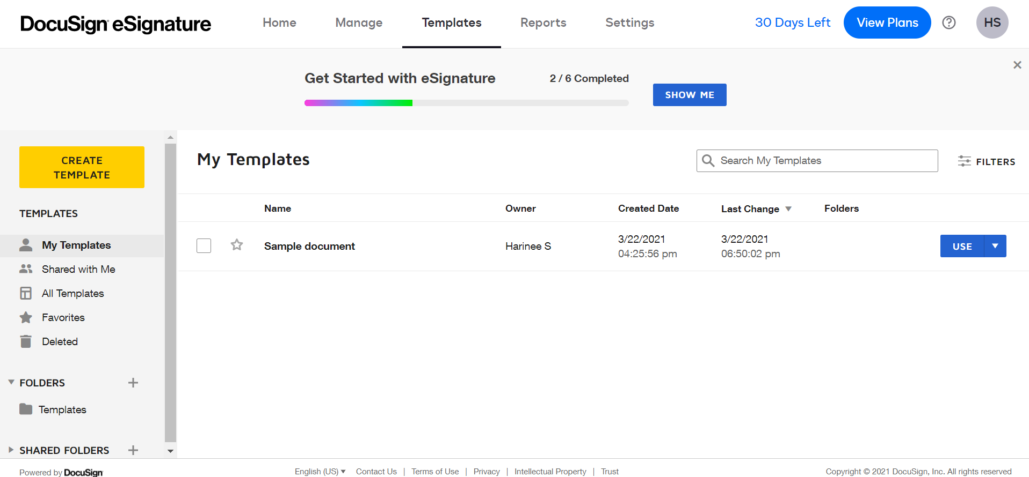

* Add that account in DocuSign setup tab

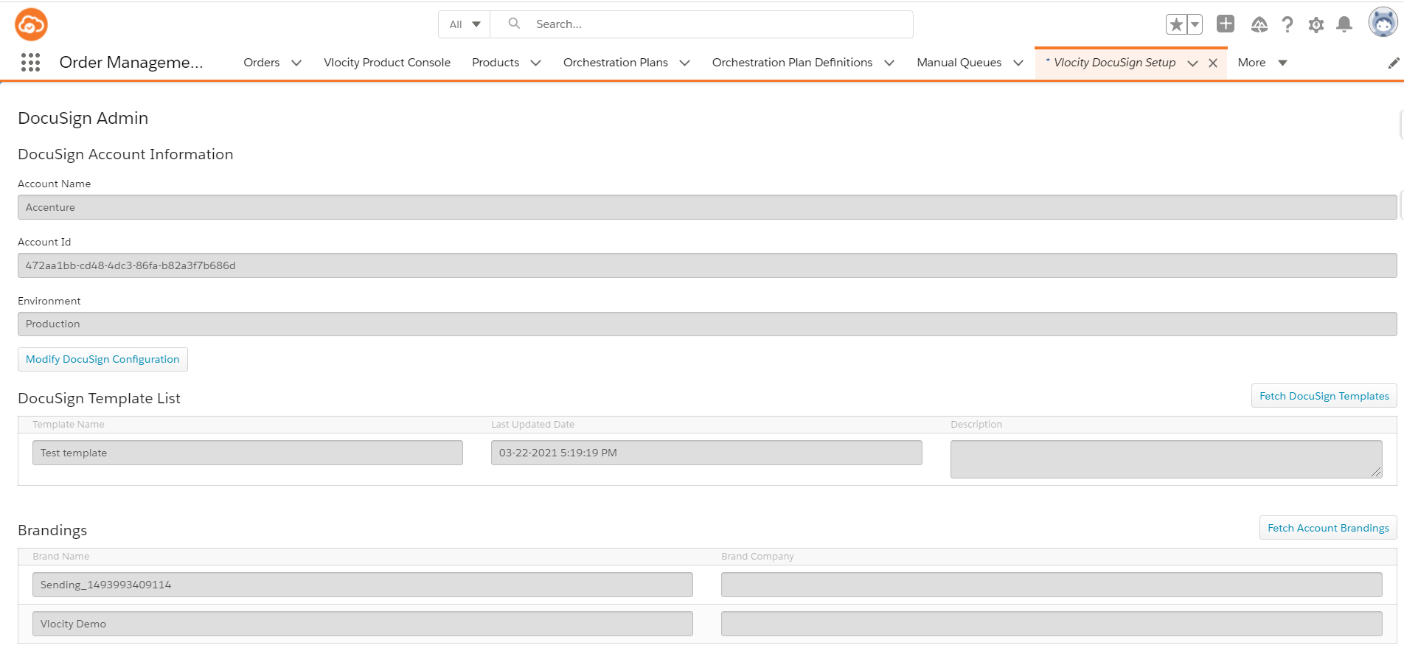

* Configure the correct Remote Site Settings

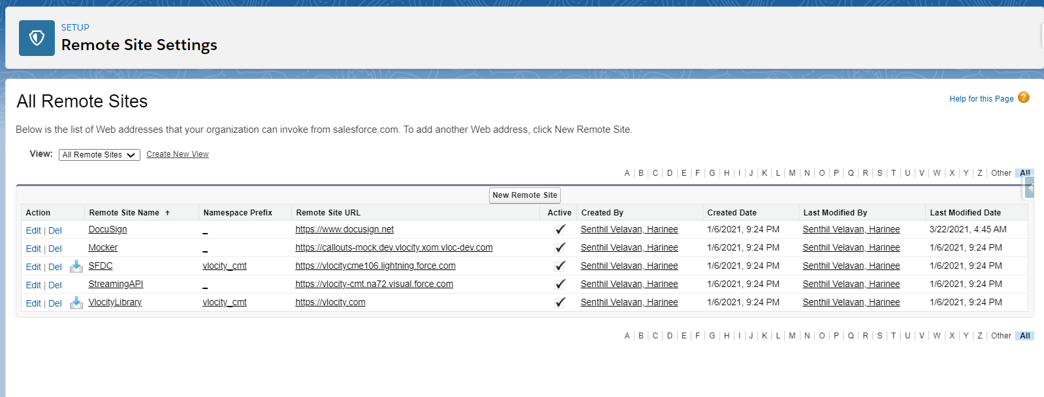

* Install the Docusign managed package

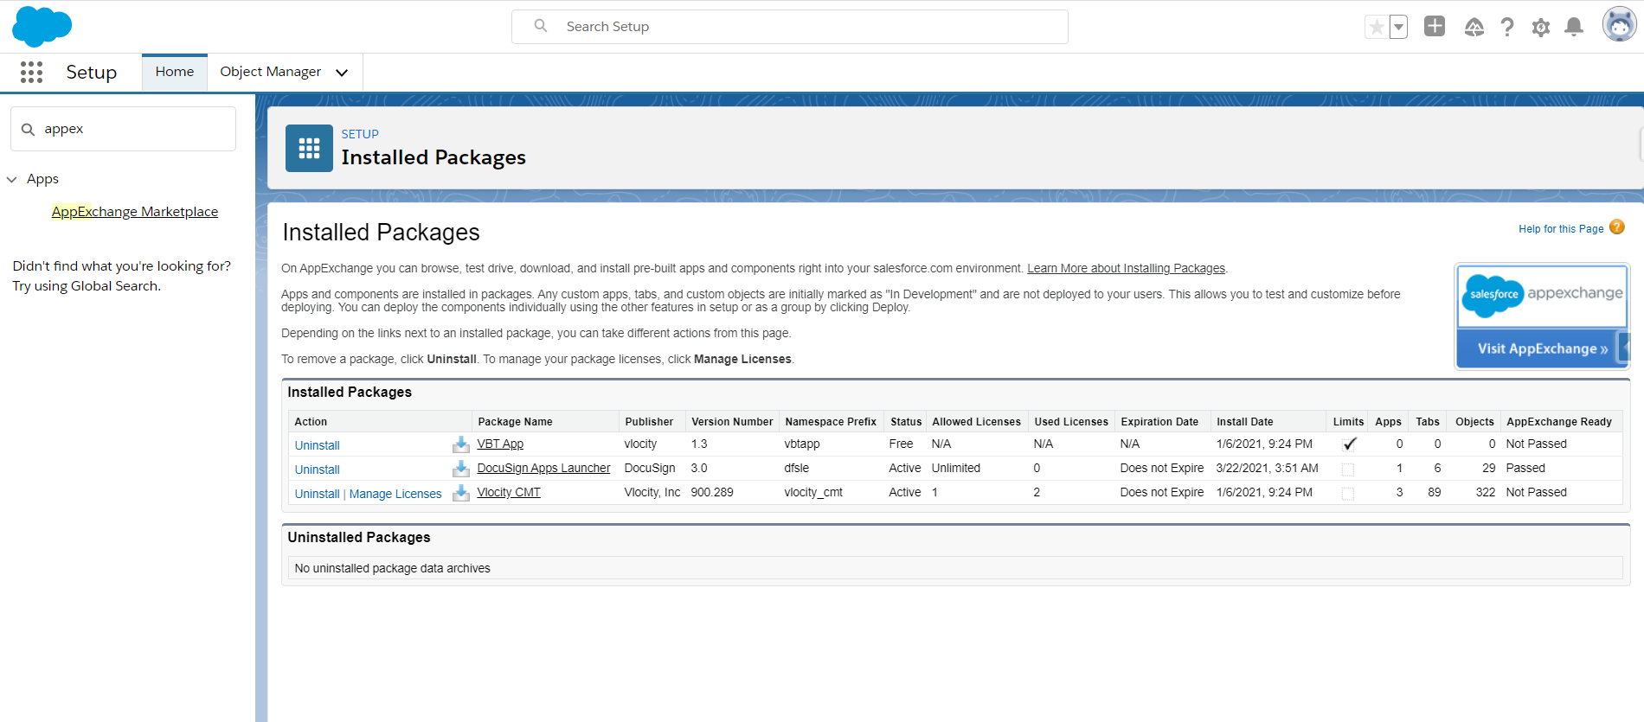

* Create a Vlocity Docusign Template

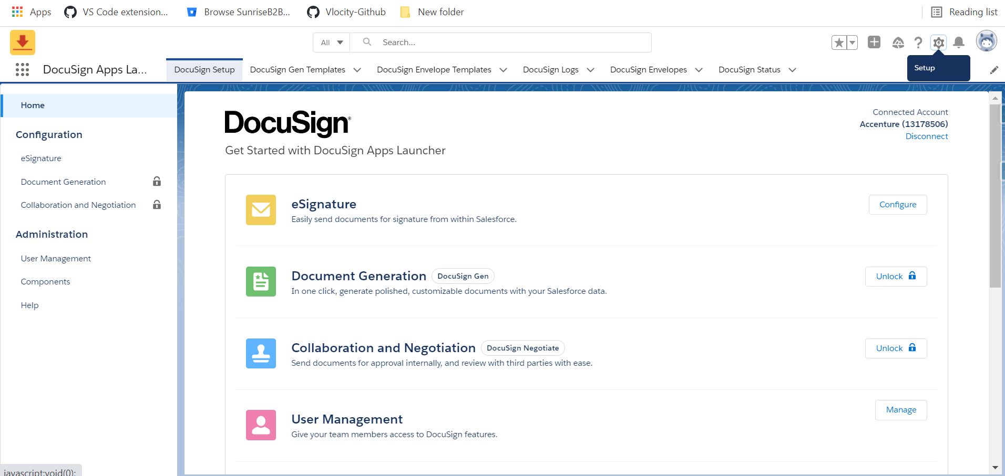

* Click on Configure

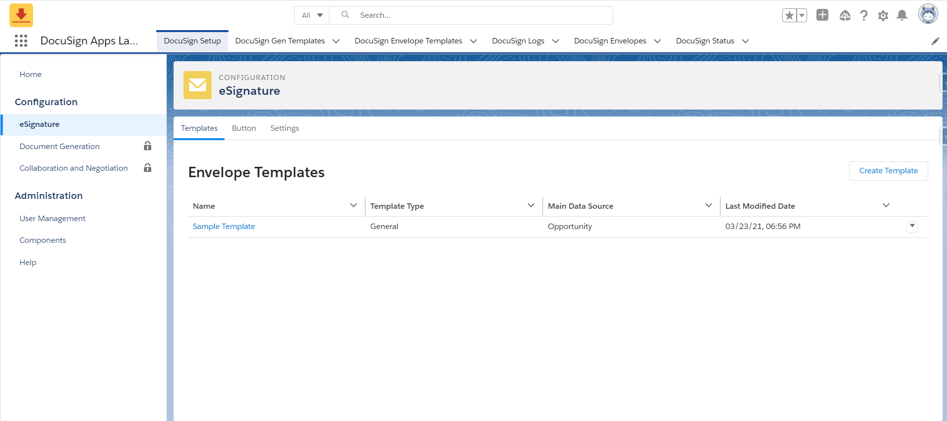

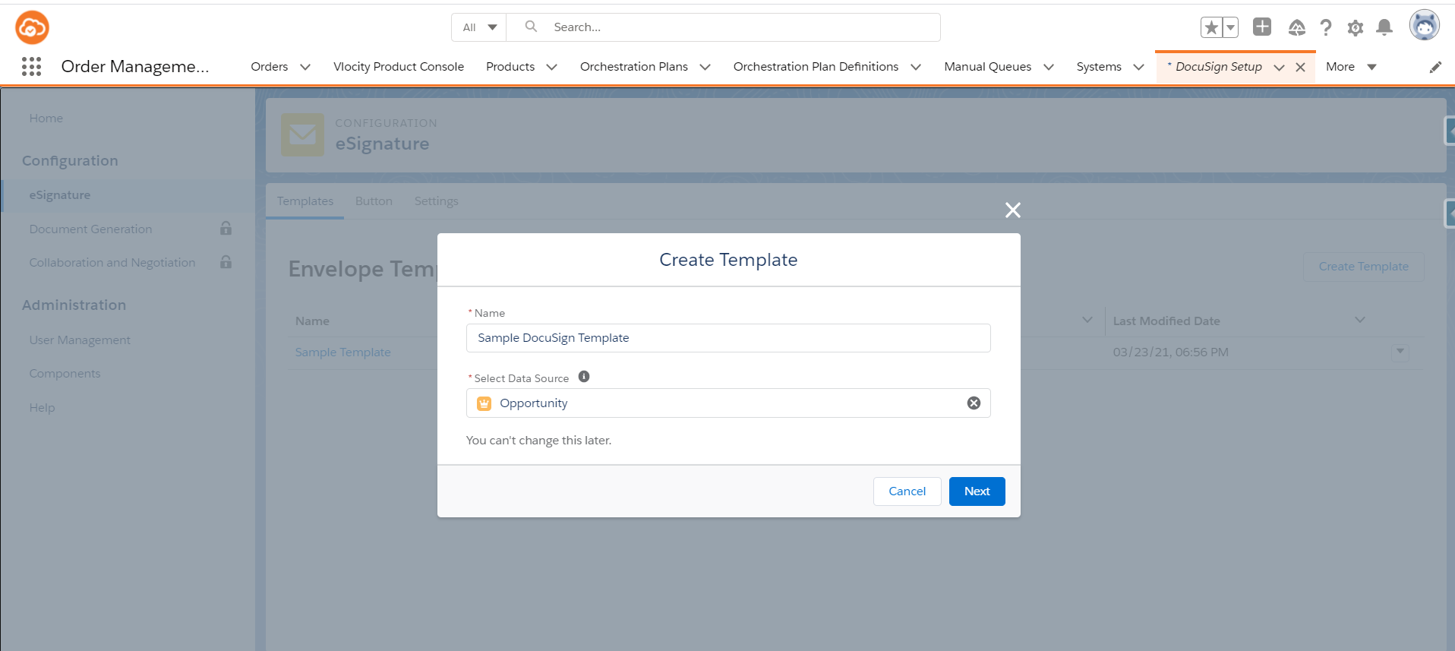

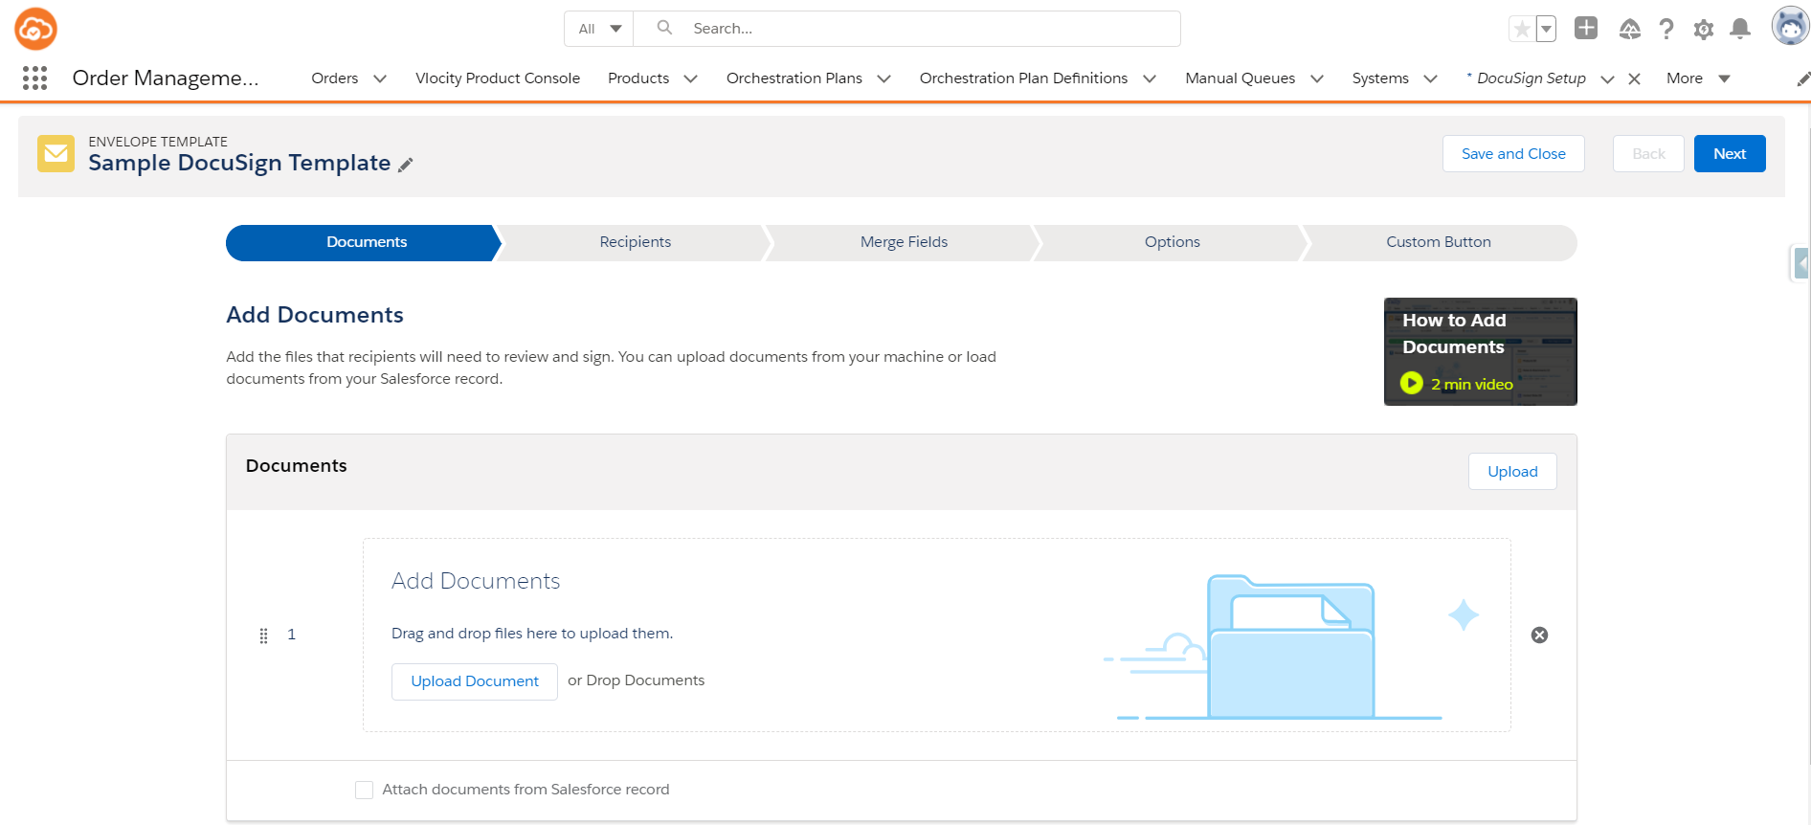

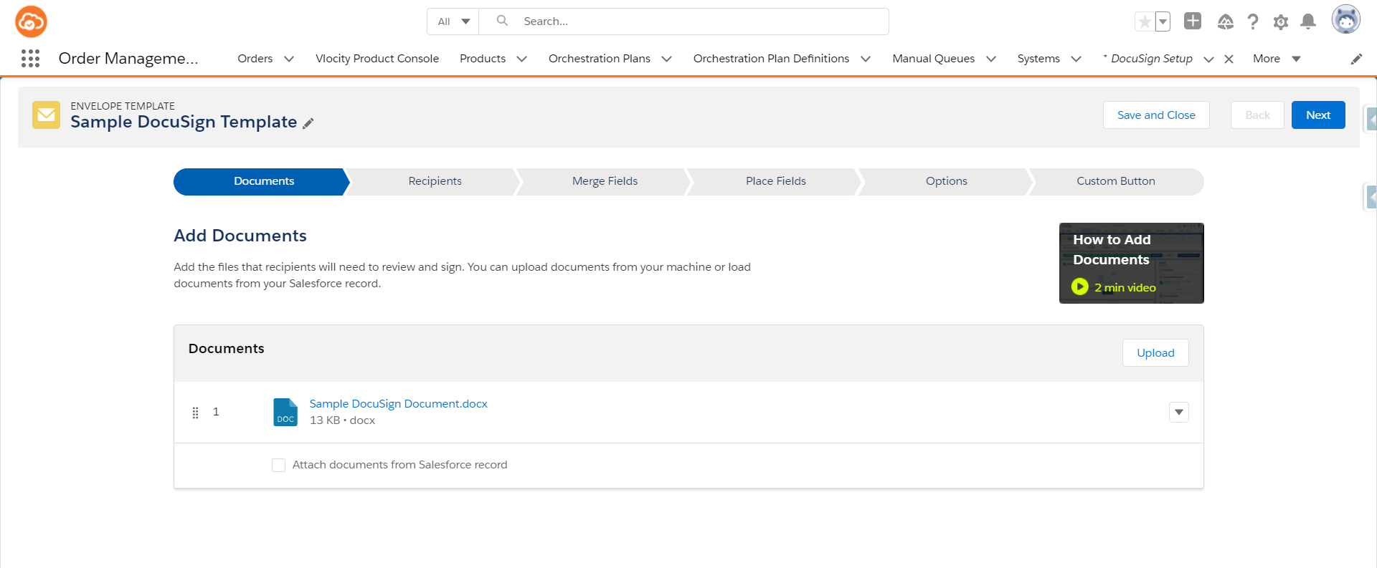

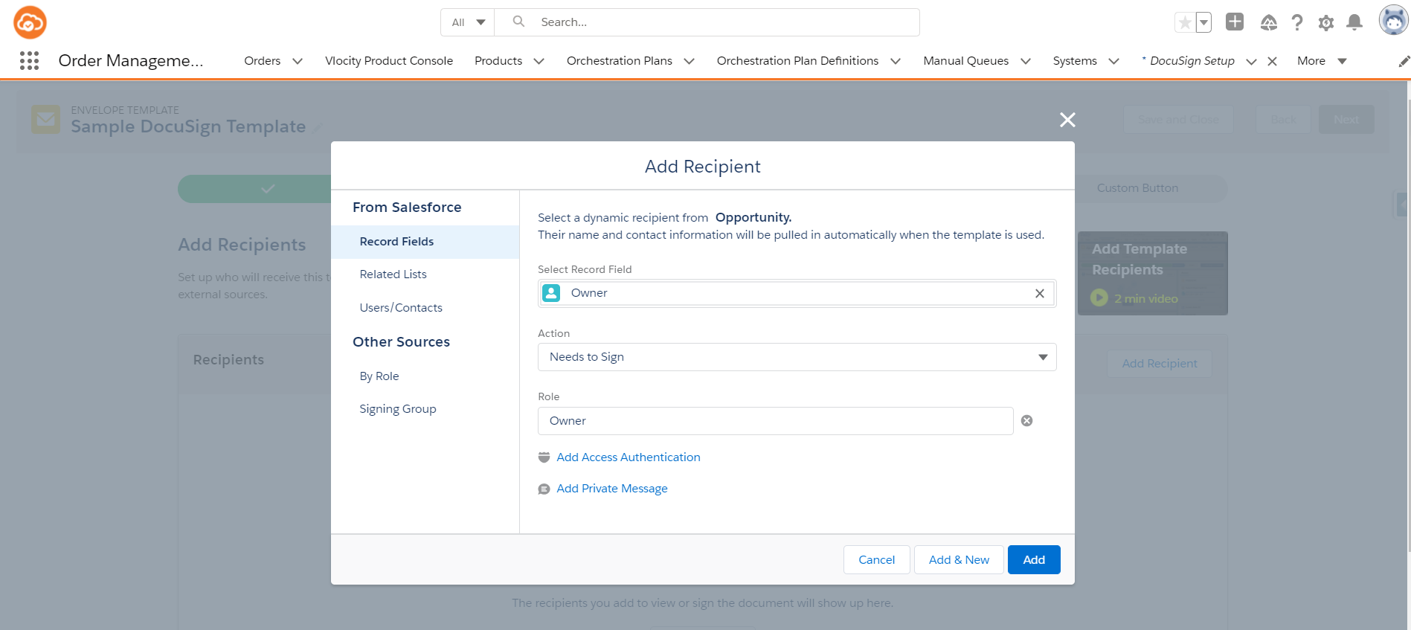

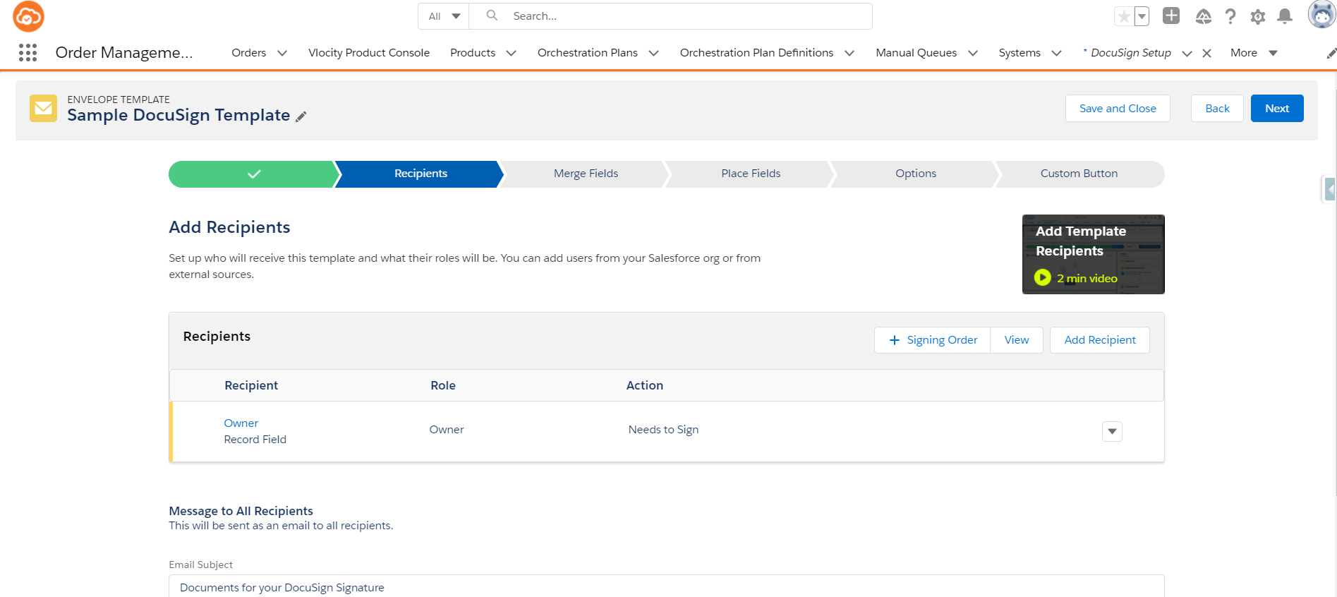

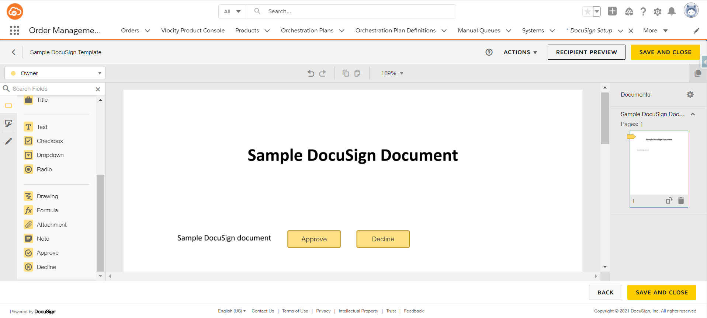

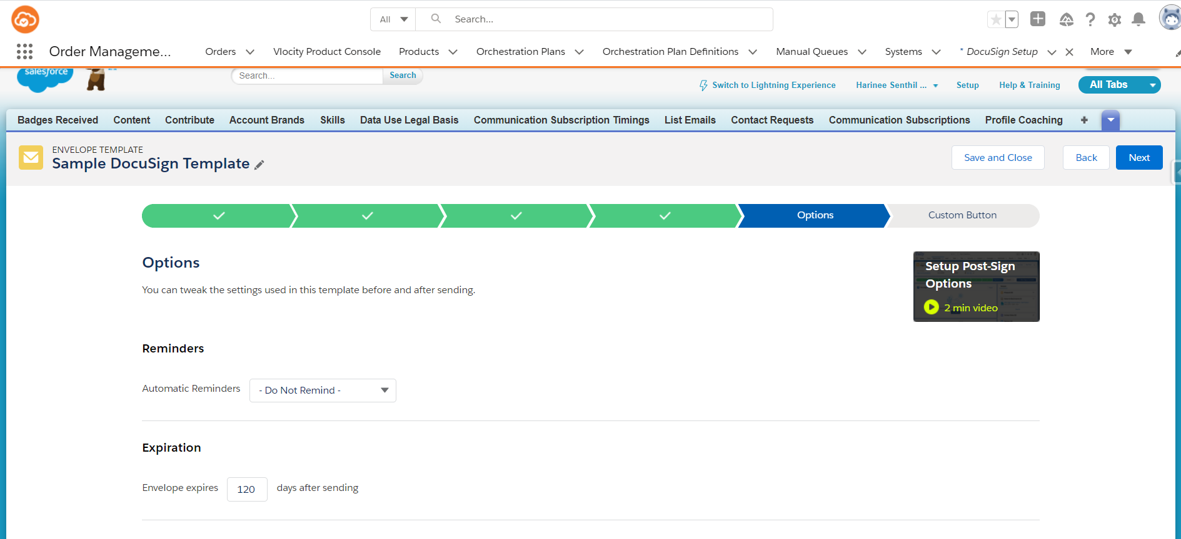

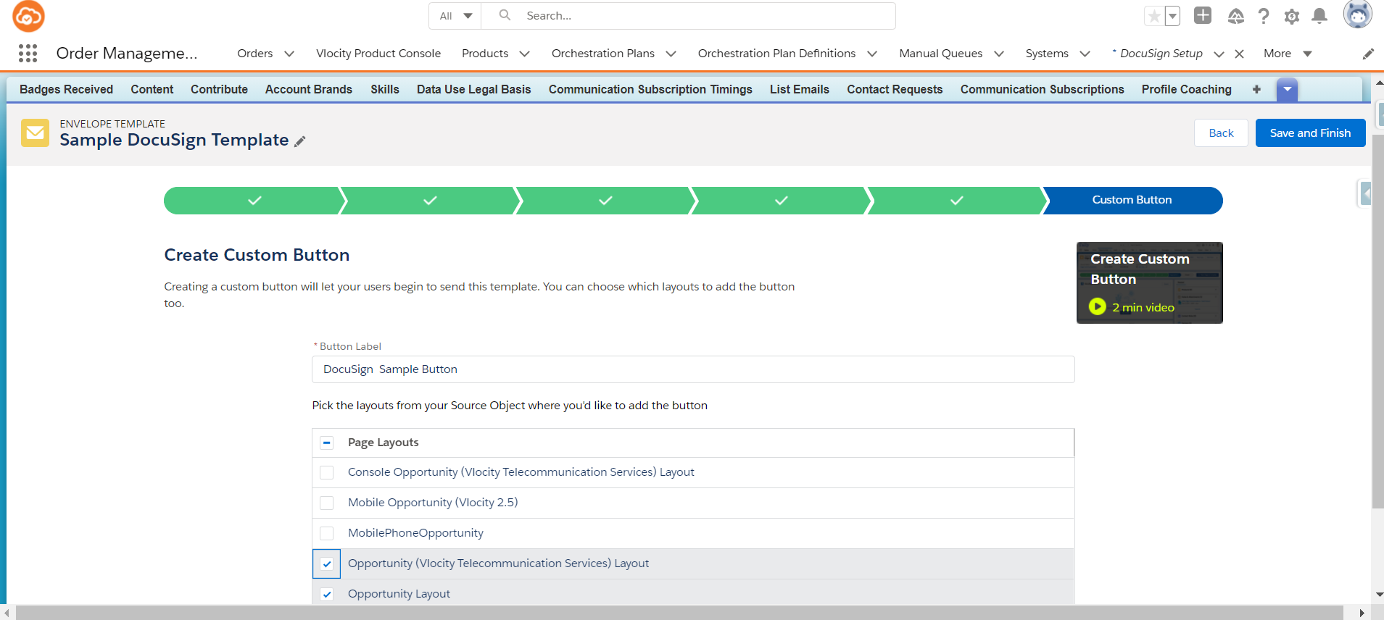

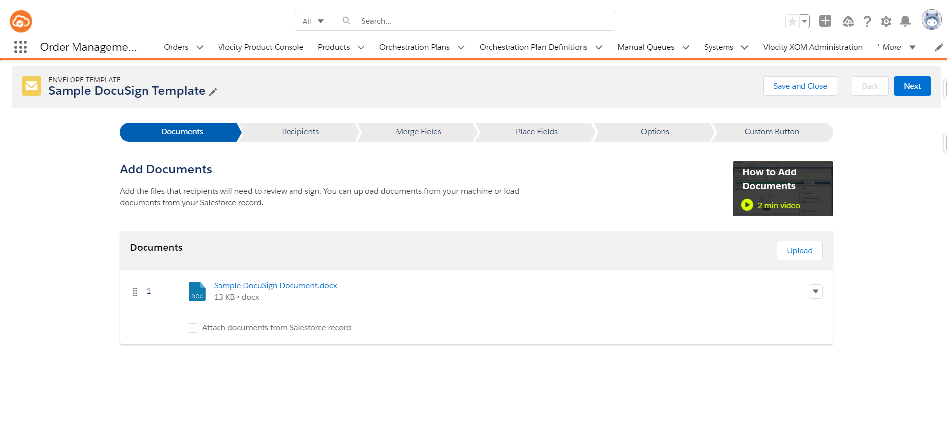

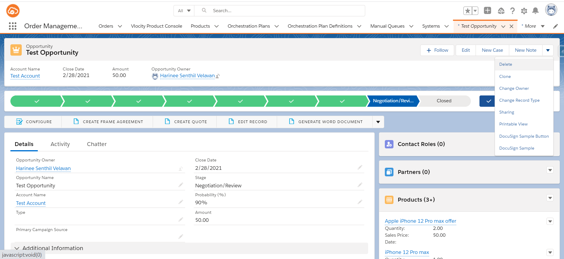

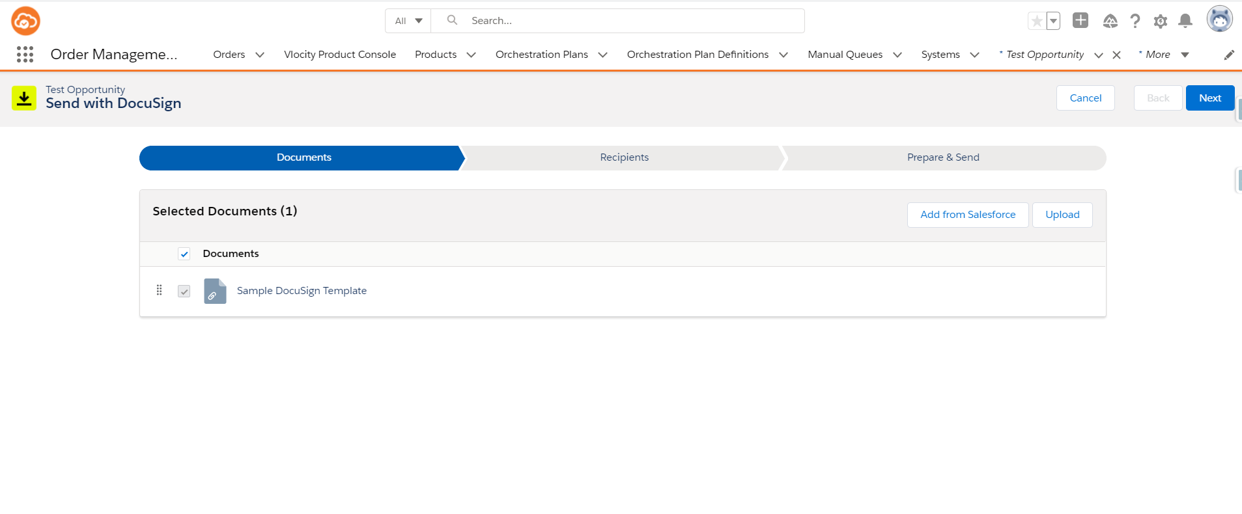

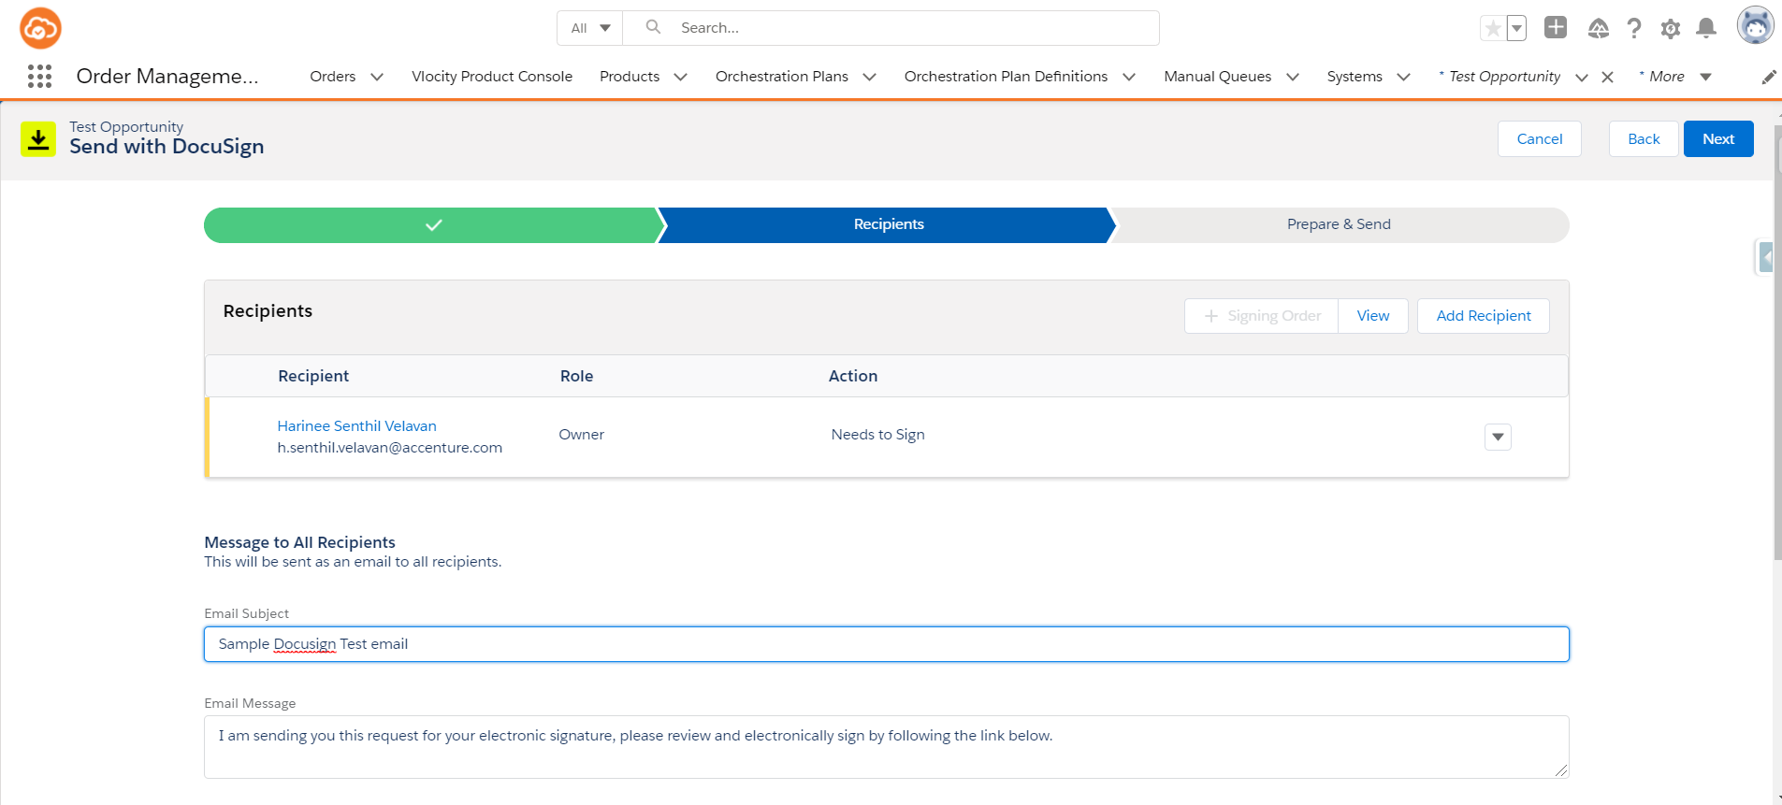

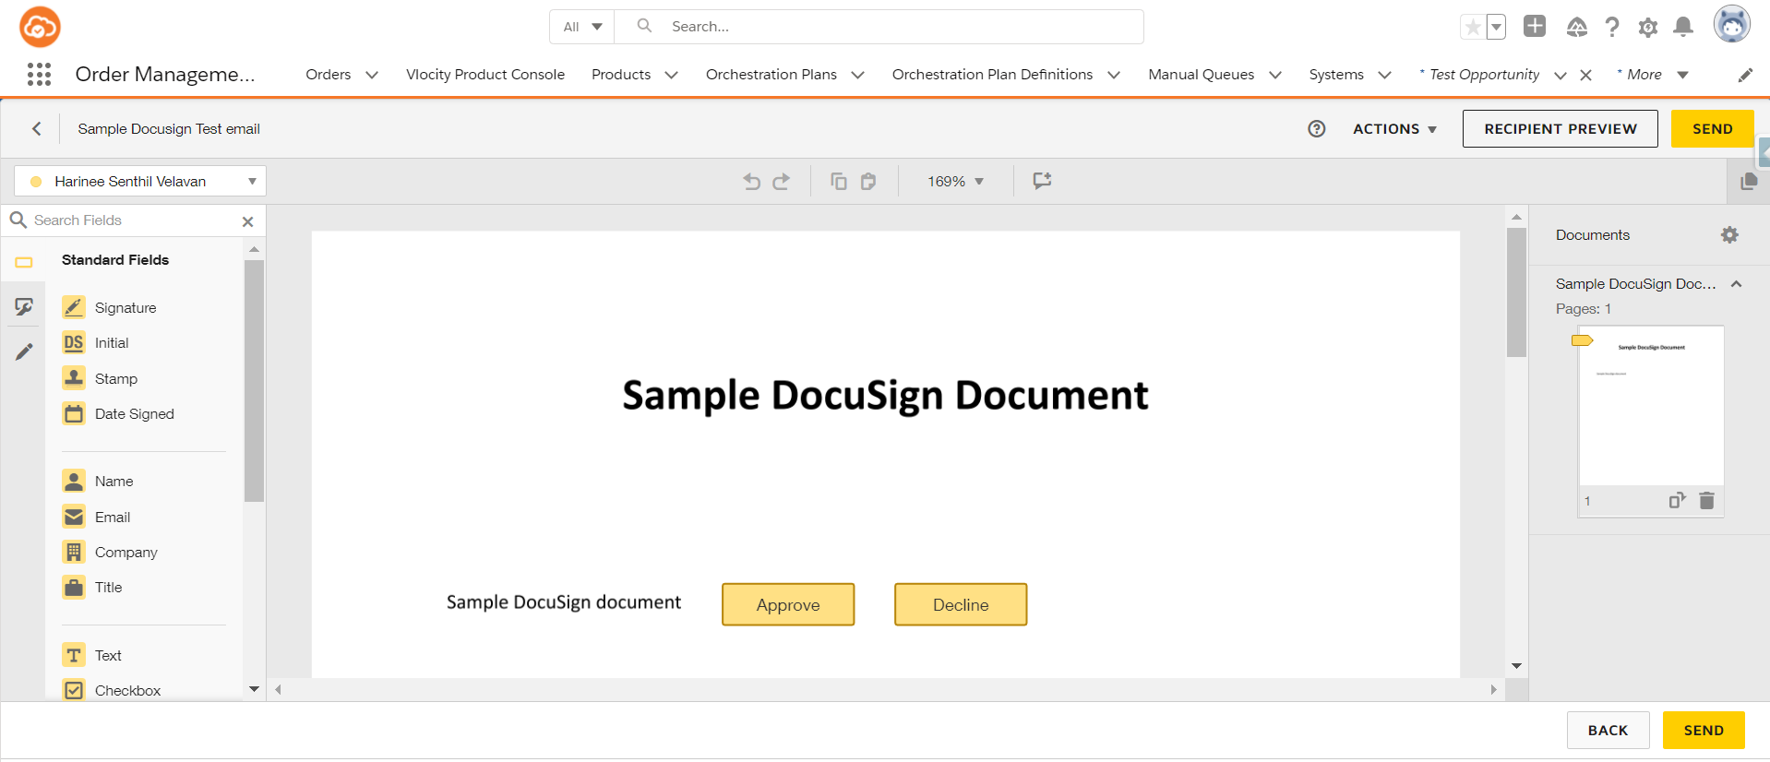

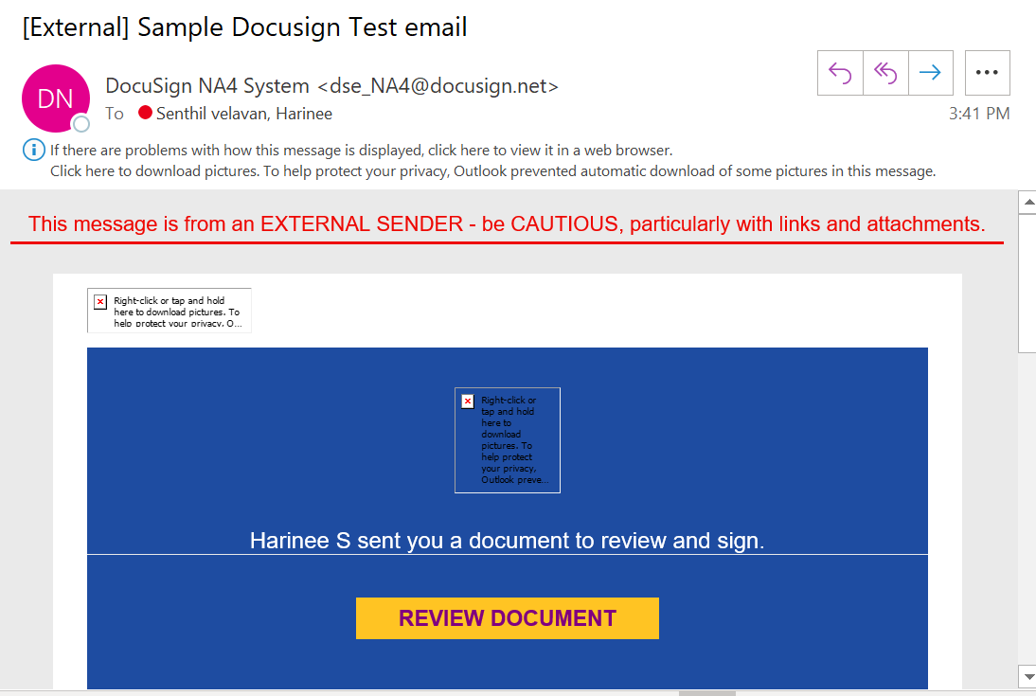

* Click on Review button

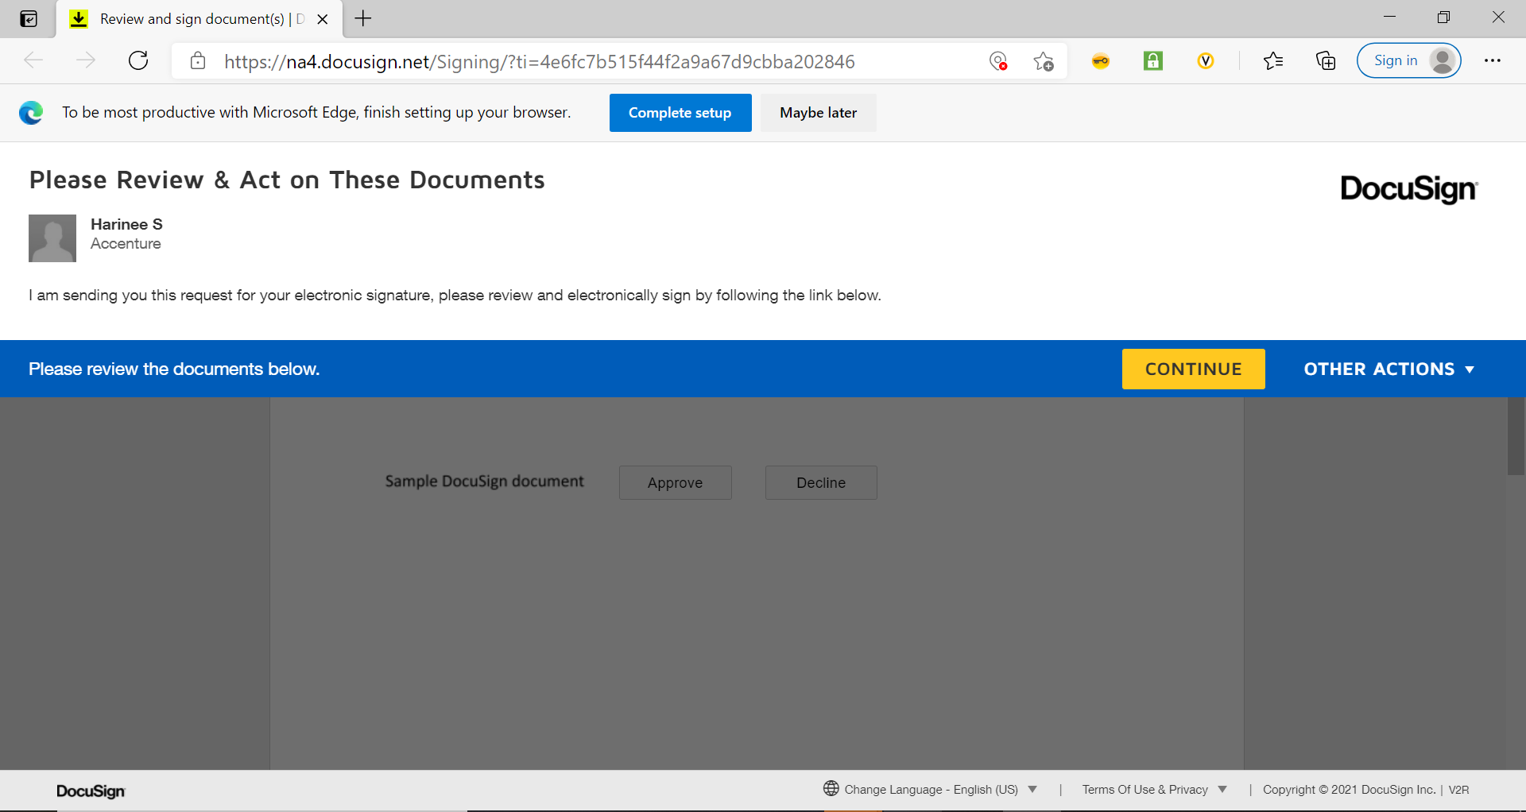

* Click on Approve button

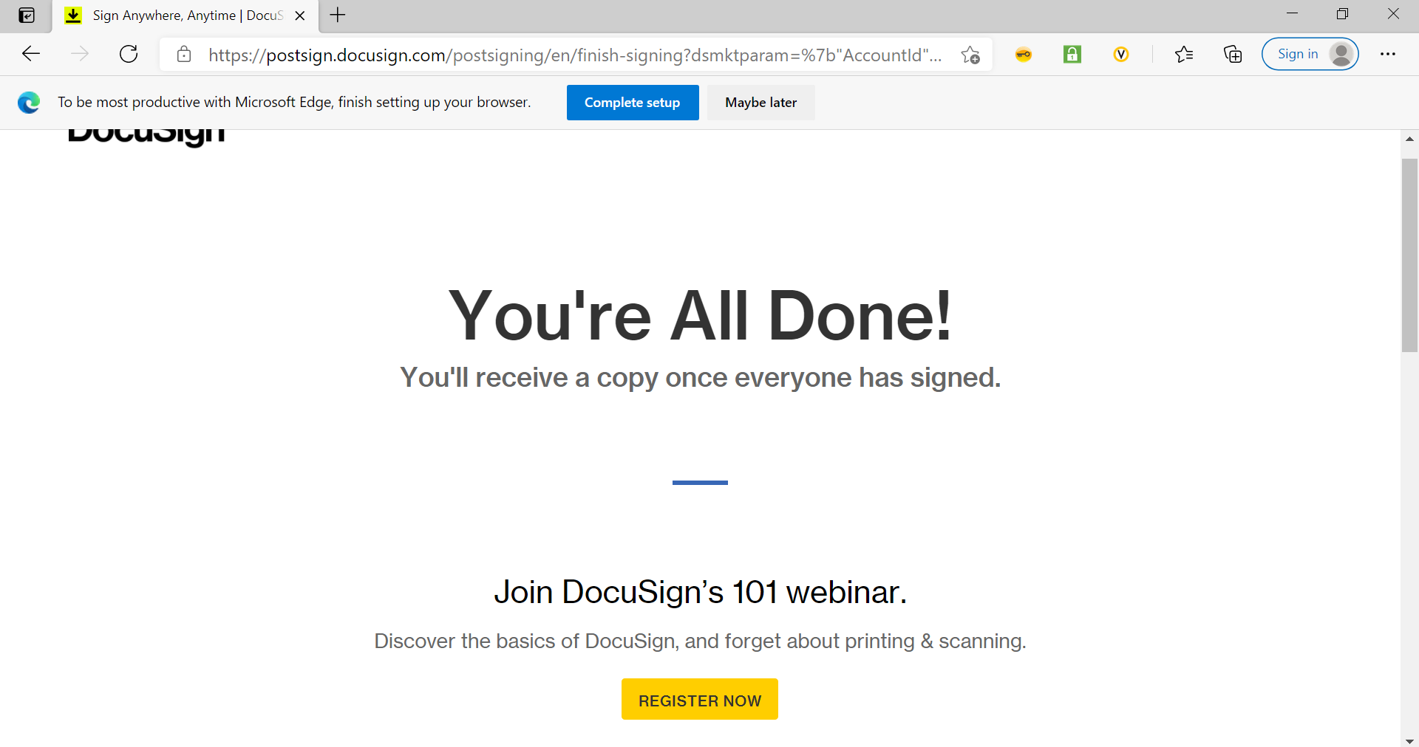

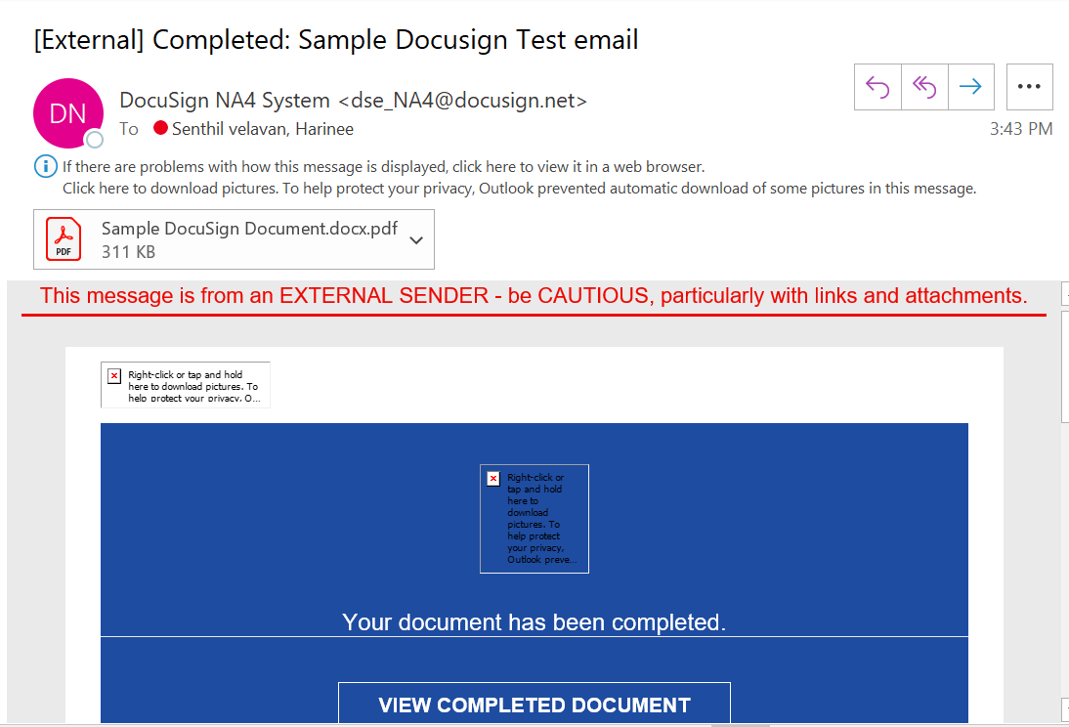

* Click on Completed Document button

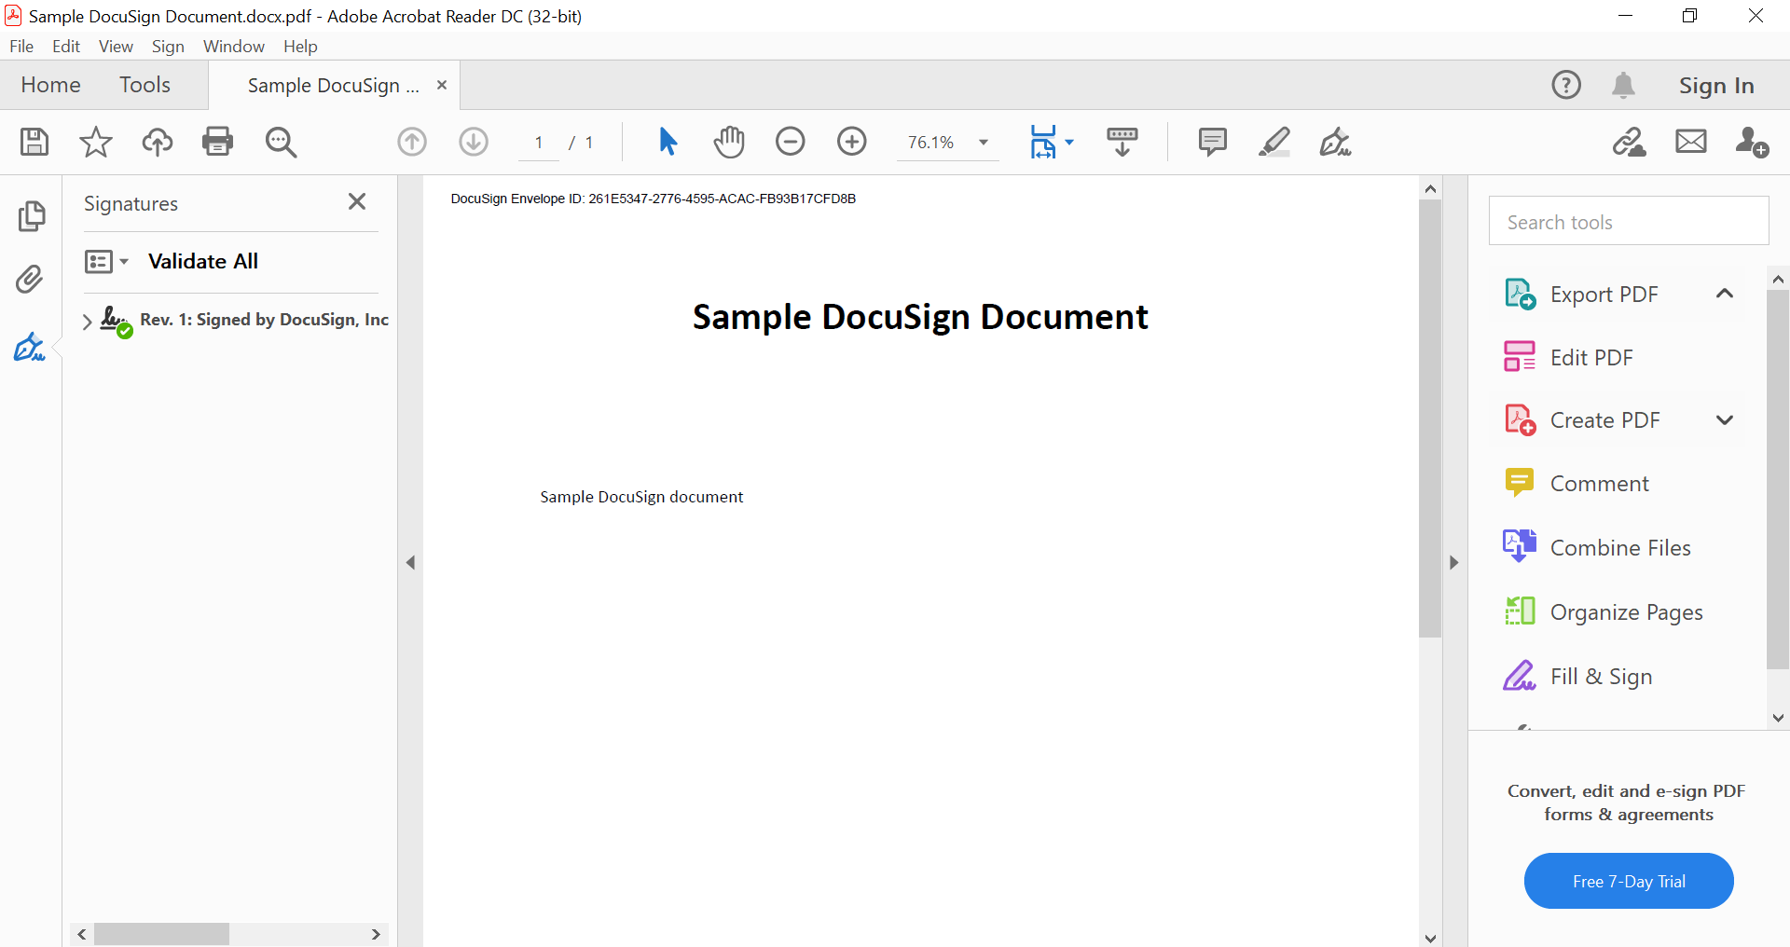

**Reference links:**

[**https://www.mstsolutions.com/technical/docusign-integration-with-salesforce-using-api/**](https://www.mstsolutions.com/technical/docusign-integration-with-salesforce-using-api/)

[**https://docs.vlocity.com/en/OmniScript-Action-Components.html**](https://docs.vlocity.com/en/OmniScript-Action-Components.html)

[**https://docs.vlocity.com/en/DocuSign-Envelope-Action-Properties.html**](https://docs.vlocity.com/en/DocuSign-Envelope-Action-Properties.html)

[**https://docs.vlocity.com/en/Integrating-DocuSign-with-OmniScript.html**](https://docs.vlocity.com/en/Integrating-DocuSign-with-OmniScript.html)

[**https://docs.vlocity.com/en/Preparing-DocuSign-Documents.html**](https://docs.vlocity.com/en/Preparing-DocuSign-Documents.html)

[**https://docs.vlocity.com/en/Linking-Your-Salesforce-Org-to-Your-DocuSign-Account.html**](https://docs.vlocity.com/en/Linking-Your-Salesforce-Org-to-Your-DocuSign-Account.html)

[**https://docs.vlocity.com/en/Using-the-DocuSign-Envelope-Action-to-Email-Documents-for-Signature.html**](https://docs.vlocity.com/en/Using-the-DocuSign-Envelope-Action-to-Email-Documents-for-Signature.html)

[**https://success.vlocity.com/s/question/0D51N00004txbqnSAA/retrieve-docusign-fields-information**](https://success.vlocity.com/s/question/0D51N00004txbqnSAA/retrieve-docusign-fields-information)

